ENGINEERING MECHANICS

**DESIGN OF ROOF TRUSS**

ADITYA SINGH 2K19/EP/005

horizontal line

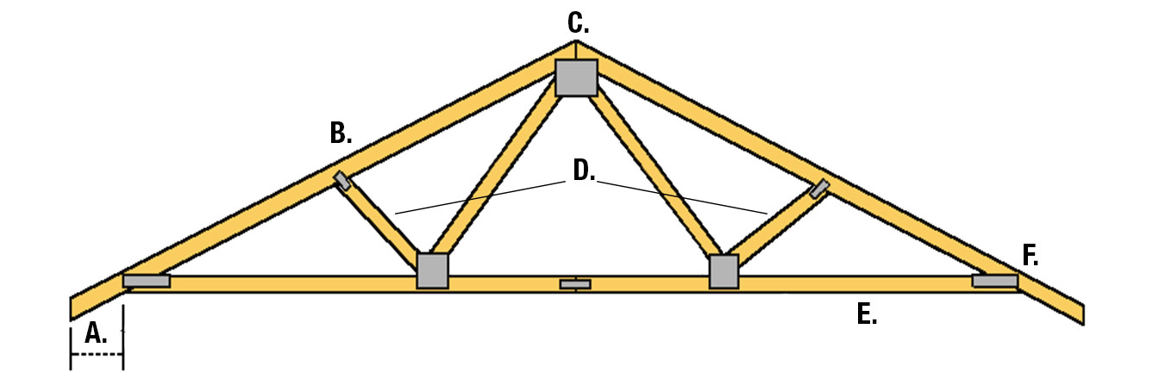

# OBJECTIVE

# Assessment of dead load, live load and wind load, Design of members of a truss, Detailing of typical joints and supports. A python program for animating deforming of truss.

# INTRODUCTION

Industrial buildings are low rise structures characterized by their low height, lack of interior floors, walls or partitions. The roofing system for such buildings is truss with roof covering material. Trusses are triangular formations of steel sections in which the members are subjected to essentially axial forces due to externally applied load. Trusses are frequently used to span long lengths in the place of solid web girders.

# COMPONENT PARTS OF ROOF TRUSS

a) **Principal Rafter (PR)** - It is the top chord member of truss subjected to only compressive force due to gravity load if the purlins are supported at nodes. If the purlins are intermediate nodes then the PR will be subjected to bending moment.

b) **Principal Tie (PT)** - The lower chord of truss is known as principal tie and carries only tension due to gravity loads.

c) **Strut** - The members of roof truss other than PR and PT subjected to compressive force are termed as strut.

d) **Sling** - The members of roof truss other than PR and PT subjected to tensile force are termed as sling.

e) **Purlin** - These are the flexural members carrying the roof and roof covering loads and distributing it over truss members.

f) **Bracings** - The member of truss which makes it stable for accidental loads, out of plane loads or lateral loads is termed as bracing system.

# LOADS ON ROOF TRUSSES

### 1. Dead Load (DL) - The DL of the truss includes the weight of roofing material, purlins, bracings, and truss load. The unit weight of different materials is given in IS875 part I. An empirical formula to calculate the approximate dead weight of truss in N/m2 is ( The weight of bracing may be assumed between 12 to 15 N/m2 of the plan area. The design of purlin based on the roofing material load is already done therefore the weight of purlin can be considered for the design directly.

2. **Live Load (LL)** - IS 875 gives the live loads acting on inclined roof truss depending upon the inclination of PR and access provided or not above the roof.

|  |  |  |
| --- | --- | --- |
| **Roof Slope** | **Access** | **Live Load** |
| <= 10° | Provided | 1.5kN/m2 of plan area |
| > 10° | Not Provided | 0.75 kN/m2 of plan area |
|  | For roof membrane sheets or purlins the live load is to be calculated by 750-20(θ-10°) in N/m2 | |

3. **Wind Load (WL)** – Wind loads are most critical loads in design and analysis of industrial roof trusses. The design wind pressure for roofs or wall cladding must be designed using the pressure difference between the opposite faces of such elements to account for internal and external pressure exerted on the surface.

The wind force F on element is obtained by **F= (Cpe-Cpi) APd**

1. External pressure coefficient (Cpe) - The average external pressure coefficient and pressure concentration coefficient for pitched roofs of rectangular clad buildings shall be as below table where no pressure concentration coefficients are given.
2. Internal pressure coefficients (Cpi) - The internal air pressure may be positive or negative depending on the direction of flow of air in relation to openings in the buildings. Two design conditions shall be examined, one with an internal pressure coefficient of +0.2 and another with an internal pressure coefficient of -0.2. 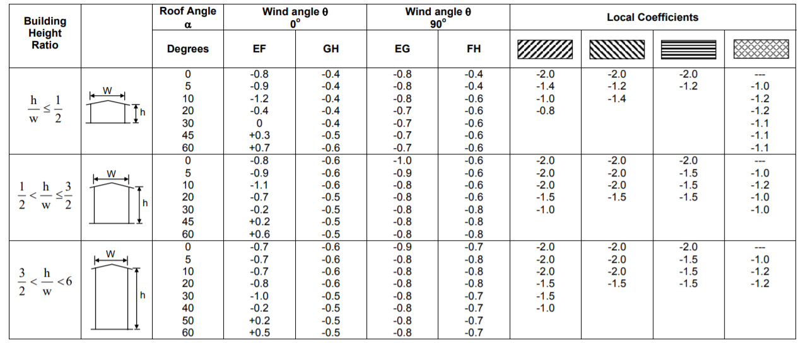
3. Inclined Area (A) – Inclined area is calculated using spacing of truss multiplied by the panel length of principal rafter.
4. Design wind pressure (Pd) - The design wind pressure at any height above mean ground level shall be obtained by the following relationship between wind pressure and wind velocity: pz = 0.6 vz2 ,where pz = design wind pressure in N/m2 at height z, and v = design wind velocity in m/s at height z.
5. Design wind speed (Vz)- The basic wind speed (V) for any site shall be modified to include the following effects to get design wind velocity at any height (Vz) for the chosen structure: 1) Risk level; 2) Terrain roughness, height and size of structure; and 3) Local topography. It can be mathematically expressed as follows:

**Vz=VbK1K2K3**

**K1 = probability factor (risk coefficient)**

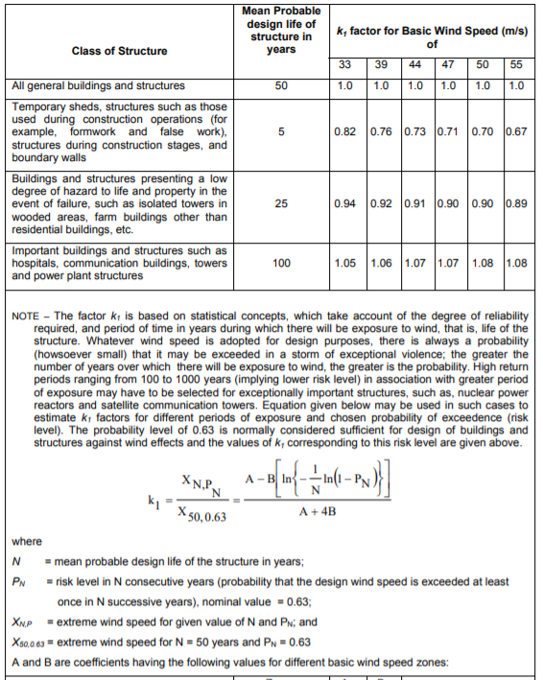

**K2 = terrain, height and structure size factor**

Terrain – Selection of terrain categories shall be made with due regard to the effect of obstructions which constitute the ground surface roughness. The terrain category used in the design of a structure may vary depending on the direction of wind under consideration. Terrain in which a specific structure stands shall be assessed as being one of the following terrain categories: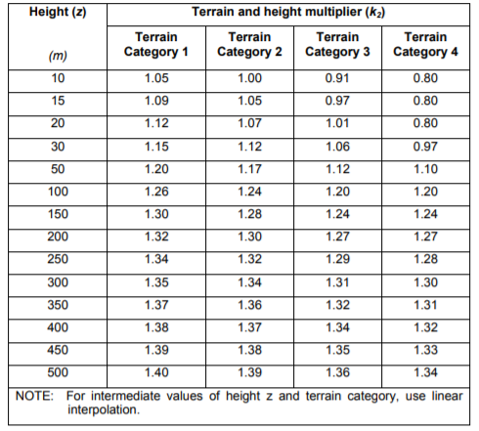

**Category 1** – Exposed open terrain with few or no obstructions and in which the average height of any object surrounding the structure is less than 1.5 m.

**Category 2** – Open terrain with well scattered obstructions having heights generally between I.5 to 10 m.

**Category 3** – Terrain with numerous closely spaced obstructions having the size of building-structures up to 10 m in height with or without a few isolated tall structures.

**Category 4** – Terrain with numerous large high closely spaced obstructions.

The buildings/structures are classified into the following three different classes depending upon their size:

**Class A** - Structures and/or their components such as cladding, glazing, roofing, etc., having maximum dimension (greatest horizontal or vertical dimension) less than 20 m.

**Class B** - Structures and/or their components such as cladding, glazing, roofing, etc., having maximum dimension(greatest horizontal or vertical dimension) between 20 to 50m.

**Class C** - Structures and/or their components such as cladding, glazing, roofing, etc., having maximum dimension (greatest horizontal or vertical dimension) greater than 50 m.

**K3 = topography factor**

The basic wind speed Vb takes account of the general level of the site above sea level. This does not allow for local topographic features such as hills, valleys, cliffs, escarpments, or ridges which can significantly affect wind speed in their vicinity. The effect of topography is to accelerate wind near the summits of hills or crests of cliffs, escarpments or ridges and decelerate the wind in valleys or near the foot of cliff, steep escarpments, or ridges.

The effect of topography will be significant at a site when the upwind slope (θ) is greater than about 3°, and below that, the value of k3 may be taken to be equal to 1. The value of k3 is confined in the range of 1 to 1.36 for slopes greater than 3°. It may be noted that the value of k3 varies with height above ground level, at a maximum near the ground, and reduces to 1.0 at higher levels.

The topography factor k3 is given by the following:

K3= 1+Cs

Where; Cs has the following values:

|  |  |
| --- | --- |
| **Slope** | **Cs** |
| 3°<θ<17° | 1.2(z/L) |
| θ > 17° | 0.36 |

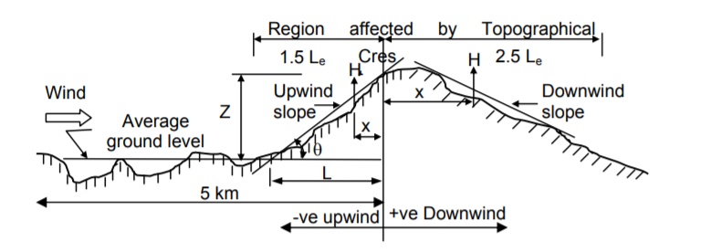

Topographical Dimensions

**PROBLEM STATEMENT**

Determine the design forces and design the members L0U1 U1L1 L0L1 of a truss where access is not provided and it is located in the city area of Nashik. Assume c/c spacing of truss 4m. Assume self-weight of purlin 100N/m, weight of bracing 80N/m2 and weight of AC sheets 130N/m2. Take Rise of truss 3m. The Length of shed is 38m and width is 18m and consider design life of 50 years. Height of the building up to eaves is 10m.

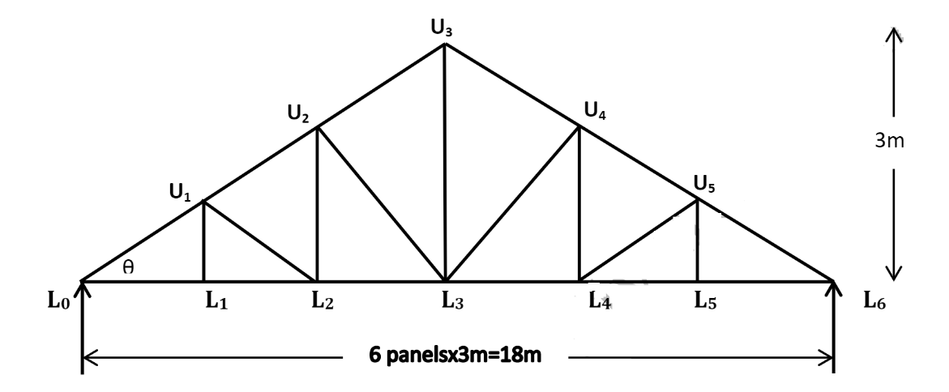

**1) Truss Geometry**

1. Length of principal rafter (L0U3) = √ [(L0L3)2 + (U3L3)2] = √ [92 + 32] = 9.4868m.
2. Length of each panel in sloping (L0U1, U1U2, U2U3) = (L0U3/No. of panels) = (9.4868/3) = 3.1622m
3. Inclination of principal rafter (θ) = tan -1 (3/9) = 18.45°
4. Length of each panel in plan = 3.1622 cos 18.45° = 2.999 = 3m
5. Plan area = (plan length x spacing of truss) = 3 x 4 = 12 m2

**2) Panel point loads due to dead load**

Weight of AC sheets = 130N/m2

Weight of bracing = 80N/m2 Self-weight of truss = 110 N/m2

Total area load = (130+80+110) = 320 N/m2

Plan load = Total area load x Plan area = 320 x 4 x 3 = 3840 N

Weight of purlin = Self weight of purlin x Spacing of truss = 100 x 4 = 400 N

**Final load on all intermediate panels due to DL = 400+3840 = 4240 N = 4.3 kN. Final load on end panels due to DL = (4.3/2) = 2.15 kN.**

**3) Panel point loads due to live load**

As Inclination of principal rafter (θ) = tan -1 (3/9) = 18.45° and the access is not provided to roof then live load is calculated as;

Live load = 750-20(θ-10°) in N/m2 = 750-20(18.45°-10°) in N/m2 = 581 N/m2

**Final live load on each intermediate panel = Live load x Plan area = 581x 4 x 3 = 7kN. Final live load on end panel = (7/2) = 3.5 kN**

**4) Panel point loads due to wind load**

As the industrial shed is having design life of 50 years and it is located in city area of nashik region, given data suggest the following conclusions,

Vb = 39 m/s, K1 = 1.0, K2 = 0.88, K3 = 1.0

Vz= Vbk1k2k3 = 39x1.0x0.88x1.0 = 34.32 m/s

Design wind pressure = pz = 0.6vz2 = 0.6x34.322 = 706.71 N/m2, Pd = 0.706 kN/m2, Height of the building is = 10m above the ground level and width of the building is 18m.

(h/w) = (10/18) = 0.55 The external pressure coefficients (Cpe) for the condition ½<h/w<3/2 and θ=18.45° from Table:

|  |  |  |  |  |
| --- | --- | --- | --- | --- |
| **Inclination of principal rafter(18.45°)** | **Wind angle θ= 0°** | | **Wind angle θ= 90°** | |
| **EF (windward)** | **GH (lee ward)** | **EG (windward)** | **FH (lee ward)** |
| 10 | -1.1 | -0.6 | -0.8 | -0.6 |
| 20 | -0.7 | -0.5 | -0.8 | -0.6 |
| **18.45°** | **-0.762** | **-0.515** | **-0.8** | **-0.6** |

Assuming normal permeability for the industrial building; Cpi= ±0.2, A = 3.1622 x 4 = 12.65 m2, Cpe = -0.8, Pd = 0.706 kN/m2

Total wind load on panel = (-0.8 - -0.2) 12.56 x 0.706 = -5.32 kN (Suction)

Total wind load on panel = (-0.8 - +0.2) 12.56 x 0.706 = -8.86 kN (Suction)

**Final wind load on intermediate panel = -8.86 kN**

**Final wind load on end panel = - (8.86/2) = -4.43 kN**

5) Determining the member forces in L0U1 U1L1 L0L1 by method of joints for all types of loadings.

1. **Member forces due to dead load-** 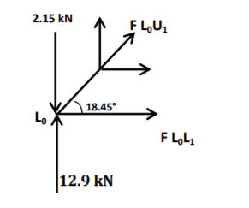

∑Fy=0, RL0 + RL6 = (2.15X2 + 4.3X5) = 25.8 kN,

RL0 = RL6 = (25.8/2) = 12.9kN

Joint L0: ∑Fy=0; **FL0U1= -34kN (Compressive)**

∑Fx=0; **FL0L1 = (34 cos18.45°) = 32.25 kN (Tensile)**

Joint L1: ∑Fy=0; **FL1U1=0** …Zero force member

∑Fx=0; -FL0L1 + FL1L2 = 0, **FL1L2 = 32.25 kN (Tensile)**

1. **Member forces due to Live load-**

Similarly performing calculations for live load the member forces are calculated as;

**FL0U1= -55.296kN (Compressive)** 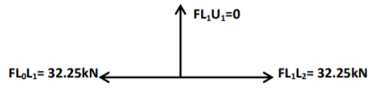

**FL0L1 = 52.45 kN (Tensile)**

**FL1L2 = 52.45 kN (Tensile), FL1U1=0**

1. **Member forces due to Wind load-**

Similarly performing calculations for wind load the member forces are calculated as;

**FL0U1= 66.09 kN (Tensile), FL0L1 = -61.25 kN (Compressive)**

**FL1L2 = -61.25 kN (Compressive), FL1U1=0**

|  |  |  |  |  |  |  |
| --- | --- | --- | --- | --- | --- | --- |
| **Members** | **Member force (kN) due to** | | | **Design Forces (kN)** | | |
| **DL** | **LL** | **WL** | **1.5 (DL +LL)** | **1.5 (DL +WL)** | **1.2 (DL + LL+WL)** |
| FL0U1 | -34.00 | 55.29 | 66.09 | **-133.93** | **+48.13** | -27.840 |
| FL0L1 | 32.25 | 52.45 | -61.25 | **+127.05** | **-43.50** | +28.14 |
| FL1U1 | 0.00 | 0.00 | 0.00 | 0.00 | 0.00 | 0.00 |
| FL1L2 | 32.25 | 52.45 | -61.25 | **+127.05** | **-43.50** | +28.14 |

Design of force table, By considering above forces and their nature i.e. negative force as compression member whereas positive force as tension member can be designed.

**PYTHON SIMULATION**

**TrussPy** is a 3D **Truss**-Solver written in **Py**thon which is capable of material and geometric nonlinearities. It uses an object-oriented approach to structure the code in meaningful classes, attributes and methods.

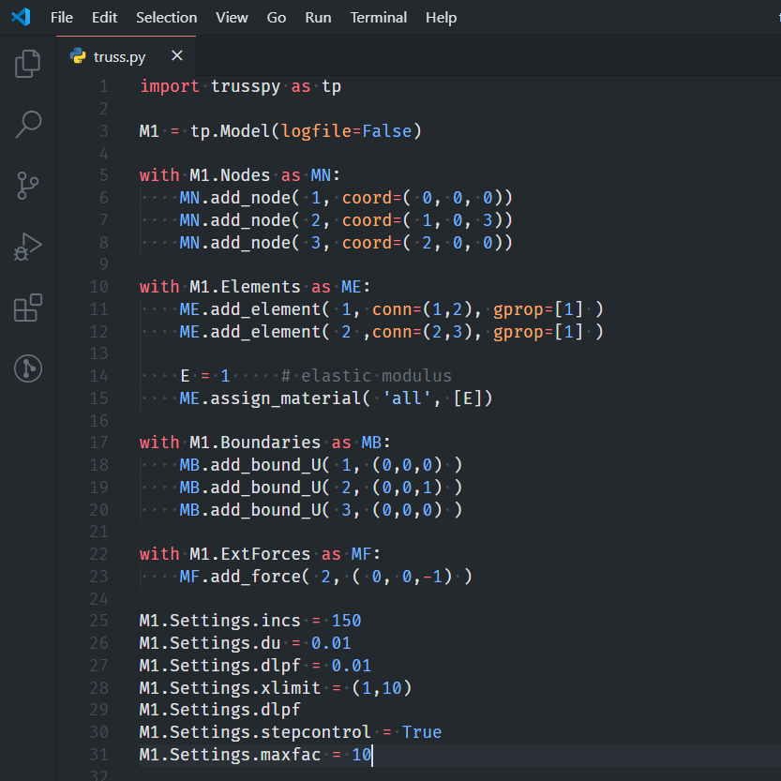

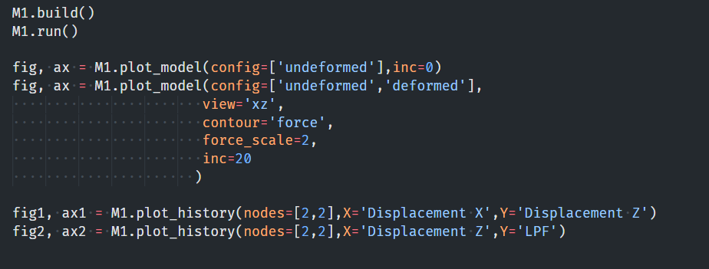

Animation of the deformation process for the Model with geometric imperfection

**THANK YOU**